Automatic Screen Printing Machine

The basic process of screen printing involves creating a stencil on a mesh screen and then pushing the ink to create and imprint the design on the below surface. The most common surface used in screen printing is paper and fabric, but metal, wood, and plastic can also be used.
This is a manual process that involves an operator manually placing the object to be printed upon, then placing a screen/stencil on top of the object and then pushing the ink over the surface to print the screen. Well here we automate this process using a smart mechanism for screen printing.
The system provides the following advantages:
- Automatic Screen Placement
- Automatic Ink Pushing over Screen
- Minimum Manual Efforts
- Faster Process
The system makes use DC motors, Connecting Arms, Ball Screw Mechanism, Gears, Shafts, Bearings, Couplings and electronics sensors and circuitry to develop this system. The system makes use of a witch operated screen printer system coupled with a gear based motorized lifting motion for screen placement.
The system first makes use of a switch to operate the screen placement mechanism. This mechanism is used to lower and lift the screen mesh mechanism over the object. On operating the switch, the machine operates a DC geared motor that has a gear attached to its shaft.
We now have a respective gear attached to a shaft connected to this gear. So when this Motor rotates, it rotates the corresponding gear which inturn lowers or lift the screen on top of the object. The screen mechanism now lands on 2 spring assist poles. These support poles are used to provide a lift after a print is successfully done.
Once this mechanism is lowered on the object we can now operate the other DC motor that prints on the object. For this mechanism the DC motor shaft is connected to a Screw that is connected on a bearing on the other side. We now have a nut on the screw that is connected to the ink pusher slide.
This mechanism acts like a horizontal slider used to slide the ink over the screen. On operating this motor using a switch, the slider smoothly slides and pushes ink over the screen for printing. Thus the system allows for a smooth and automatic screen printing mechanism.

Components
- DC Geared Motors
- Spring & Support Rods
- Ball Screw
- Gears
- Linkages and Arms
- Shafts & Coupling
- Bearings
- Switches & Buttons
- Atmega Microcontroller
- PCB Board
- Resistors
- Capacitors
- Transistors
- Cables and Connectors
- Base Frame
- Supporting Frame

Block Diagram

Front View

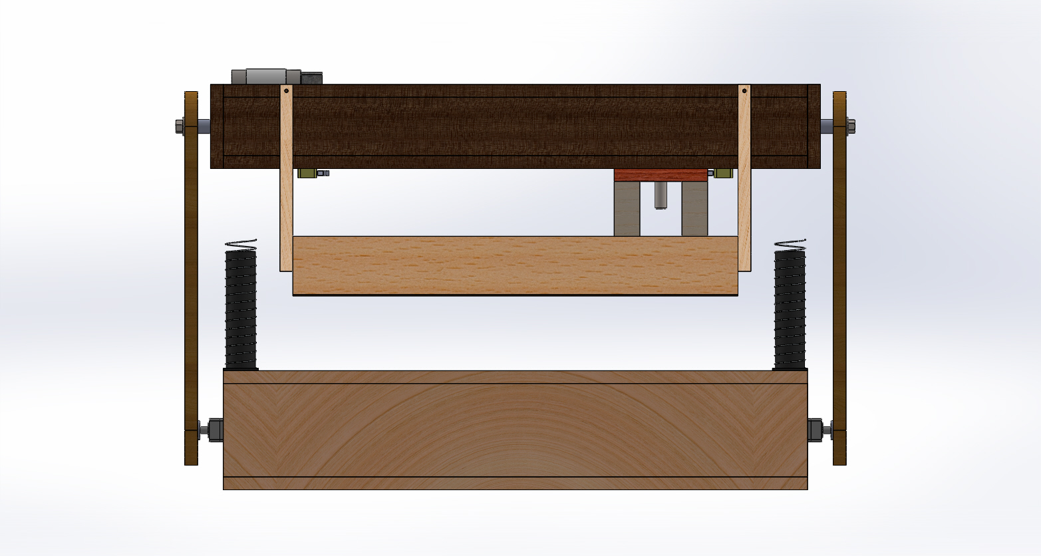

Top View
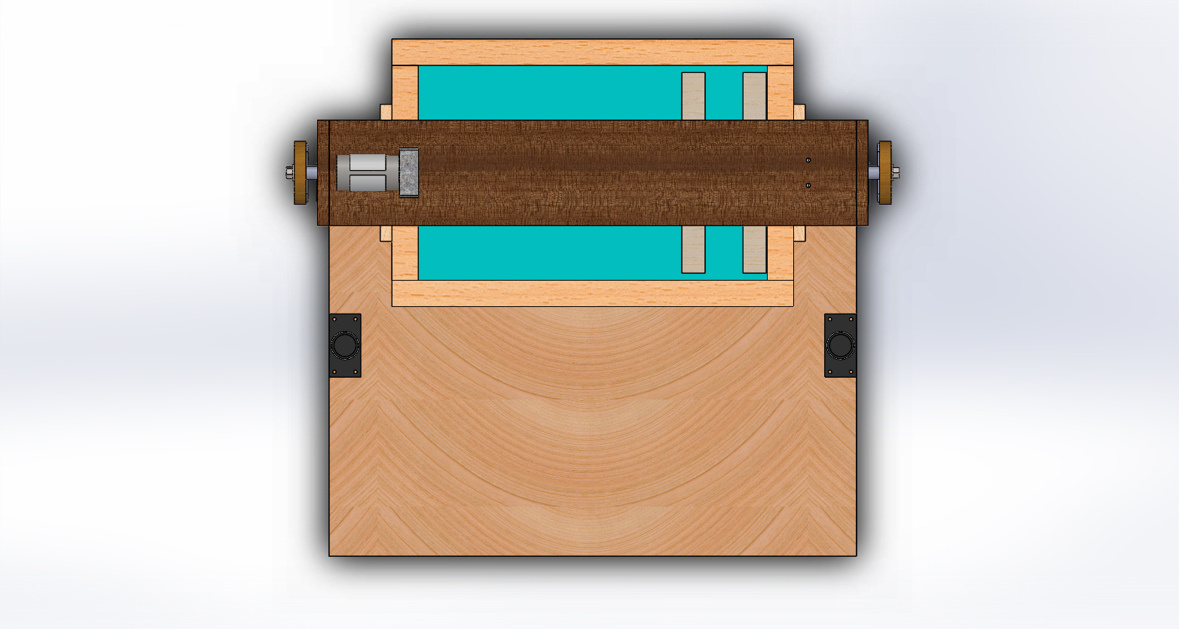
3D View
